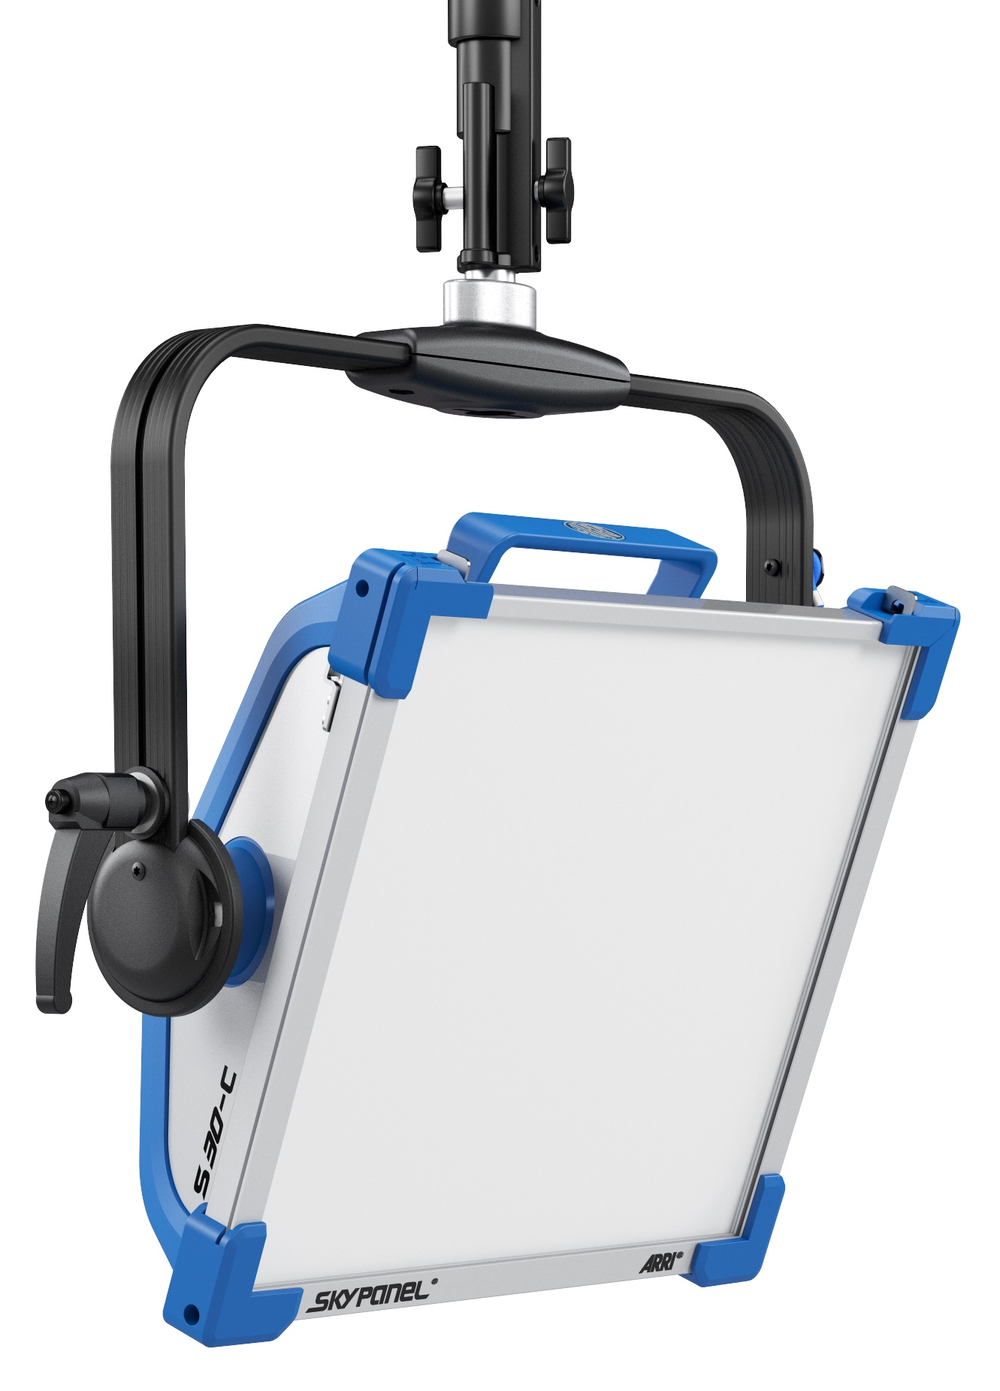
V2.0

S30-C
LED Soft Light
- General

- The luminaire shall be a RGBW LED soft light luminaire with an electronically controlled LED light source, especially with the ability to change the diffusion panel as needed.
- The luminaire shall be capable of providing fully tunable white light from 2,800 to 10,000K and allow precise manipulation of intensity, green-magenta point (full minus green and full plus green), hue and saturation, RGBW control, xy control, gel and source color selection, and built-in effects.
- The precise continuous manipulation of intensity from 0% to 100% is mandatory.
- All functions shall be controllable through USITT DMX 512-A and fully RDM compatible with a feedback channel for reporting, as well as controllable via ArtNet and sACN.
- An on-board control shall be available to control intensity, color temperature, green-magenta point, hue and saturation, RGBW, xy, gel and source selection, and effects.
- The luminaire shall be available as a manual and hanging pole operated version.

- Physical

- The luminaire shall be constructed of rugged, aluminum and molded engineering grade fiber-reinforced thermoplastics.
- The body of the fixture shall be available in blue/silver or matt black finish.
- Technical requirements for the soft light luminaire:

  - The soft light luminaire shall have dimensions not exceeding 507 mm (20”) in length, 426 mm (16.8”) in height without spigot, 559 mm (22”) with spigot, and 133 mm (5.2”) in width.
  - Light aperture shall have a dimension of 355 mm (14”) by 300 mm (11.8”) with a sturdy accessory, barndoor and diffusion slot including a top latch to allow for additional accessories.
  - The stirrup shall be made of aluminum profile with a 28 mm (1 1/8”) / 16 mm (5/8”) combo spigot.
  - High strength tilt lock shall guaranty secure locking to eliminate any movement or slippage to ensure the luminaire will stay in position.
  - Top plastic handle for carrying of lamphead and plastic foot for allowing the fixture to stand on a flat surface.
  - A tilt range of +/- 90° is required.
  - The beam angle shall range from 72° – 114º with the changing of diffusion panels.
  - Weight for the manual version shall be 7.7 kg (17 lb.) and for the pole operated version 9.5 kg (20.9 lb.).

- The luminaire shall be equipped with cooling fans.
- The fan noise emission shall not exceed 20 dBA (1 m) at any time.
- The LED emitters used in the fixture should be rated for nominal 50,000-hour LED life to 70 % intensity with an estimated color shift over lifetime less than 200 K.
- The luminaire shall provide monitoring of the hours in use and the actual temperature.

- Electrical

- The luminaire shall be furnished with an external power supply for 110 to 240 V AC 50/60 Hz supply voltage.
- The luminaire shall require power from a non-dim source.
- The maximum power consumption shall be 200 W.
- Available power cord options shall include but not be limited to:
  - PowerCon TRUE1 TOP cable with bare ends
  - PowerCon TRUE1 TOP cable and Edison connector
  - PowerCon TRUE1 TOP cable and Schuko connector
  - PowerCon TRUE1 TOP cable and Chinese connector
  - PowerCon TRUE1 TOP cable and Japanese connector

- Only integrated light engines that will not emit light in the ultra-violet or the Infrared spectrum are acceptable.
- A control and indicator panel for on-board control shall be available.
- The fixture shall be equipped with an RDM/DMX interface.
- An XLR 5-pin DMX in and XLR 5-pin DMX through shall be implemented.
- A EtherCon LAN port shall be implemented.
- An XLR 4-Pin port shall be implemented for battery power input in the range of 23 – 36 V DC.
- An XLR 3-Pin port shall be implemented for 48 V DC power input from the SkyPanel PSU.
- The fixture shall have a USB-A port used for updating the fixture’s internal firmware, adjusting operating parameters, for service purposes, and for powering external devices.

- Optical

- The optical system shall offer an interchangeable diffusion panel with a half peak angle in the range of 72° – 114º. The luminaire should have soft, even beam of light and clean shadow rendition with following optical characteristics:
- Aperture Dimension of 355 mm x 300 mm (14” x 11.8”)
- Color rendition index CRI of > 95, TLCI of > 91
- Continuously variable correlated color temperature range from 2,800 K – 10,000 K
- Continuously variable green-magenta adjustment
- Full RGBW color gamut with hue and saturation control
- Calibrated CIE 1931 xy control
- Digital gel color selection
- Lighting effects selection
- Color temperature tolerance of +/- 100 K (nominal), +/- 1/8 Green-Magenta (nominal)

- The manufacturer shall ensure that there will be no differences in the quality of the light field between production batches of the lighting fixtures.
- The luminaire should have the following photometric characteristics:
 | 3 m / 9.8ft |  | 5 m / 16.4 ft |  | 7 m / 23.0 ft |  | 9 m / 29.5 ft
 | 3200K | 5600K | 3200K | 5600K | 3200K | 5600K | 3200K | 5600K
Standard Diffusion | 670 lx | 782 lx | 241 lx | 282 lx | 123 lx | 144 lx | 74 lx | 87 lx
Standard Diffusion | 62 fc | 73 fc | 22 fc | 26 fc | 11 fc | 13 fc | 7 fc | 8 fc
Lite Diffusion | 725 lx | 842 lx | 261 lx | 303 lx | 133 lx | 155 lx | 81 lx | 94 lx
Lite Diffusion | 67 fc | 78 fc | 24 fc | 28 fc | 12 fc | 14 fc | 7 fc | 9 fc
Heavy Diffusion | 554 lx | 643 lx | 199 lx | 231 lx | 102 lx | 118 lx | 62 lx | 71 lx
Heavy Diffusion | 51 fc | 60 fc | 19 fc | 22 fc | 9 fc | 11 fc | 6 fc | 7 fc
Intensifier | 1065 lx | 1193 lx | 383 lx | 429 lx | 196 lx | 219 lx | 118 lx | 133 lx
Intensifier | 99 fc | 111 fc | 36 fc | 40 fc | 18 fc | 20 fc | 11 fc | 12 fc

- Environmental

- The fixture shall be rated IP 20 for dry location use.
- The fixture shall operate in an ambient temperature range of -20°C (-4°F) to 45°C (113°F)
- The fixture shall be in compliance with CE standards as well as ENEC and FCC certified.
- The fixture shall be UL LISTED, or equivalent certification, to the UL1573 standard for stage and studio use.

- Operation

- It shall be possible to remote control the luminaire via DMX 512 A.
- The fixture shall be fully RDM compatible and equipped with a feedback channel for reporting.
- The fixture shall be fully Art-Net 3 enabled with DMX gateway capability.
- The fixture shall be fully sACN enabled with DMX gateway capability.
- An onboard control with dot-matrix display for intensity control and to access the menu shall be available.
- Special modes of operation should be available including, but not limited to:
  - Tungsten Mode: Mimics the behavior of a conventional Tungsten light source
  - Low End Dimming Mode: Provides lower light levels with enhanced CCT accuracy and color rendition
  - Dimming Curve Selection: Selection of four dimming curves including exponential, linear, logarithmic, and “S” curve
  - Host/Client Mode: Allows for one fixture to control a group of several other ARRI fixtures.
  - Lighting Effects: 17 different lighting effects, such as “cop car” and “fire”.
  - Extended Color Control: Allows for an additional layer of color adjustment based on color temperature, saturation, +/- red, +/- green, +/- blue, +/- cyan, +/- magenta, +/- yellow.
- Other functions and setting of the lamphead should include:
  - Display Setup: Allows for control of the display illumination, brightness, contrast, Orientation, and error display setting
  - USB Functions: Allows for the saving of presets, fixture settings and error logs to an external USB stick
  - Low Battery Warning: Allows user to set a voltage whereby the lamphead will display a warning if a battery voltage should fall below
  - DMX Settings: Allows for the adjustment of DMX address, protocol, signal loss behavior, and protocol version
  - Art-Net Settings: Allows for the adjustment of Art-Net net, subnet, universe, merge mode, state, and gateway
  - IP Settings: Allows for the adjustment of the IP Mode and IP Address with the onboard control panel
- The luminaire shall offer ten 8 bit DMX profiles, ten 16 bit DMX profiles, and five coarse/fine DMX profiles, which can be pre-configured by the user.
- Additionally, any DMX profile shall have the option to add additional channels for specifying color with Extended Color Control.

- Dimming

- The fixture shall allow continuous linear and flicker free dimming from 0 % to 100 % in an 8 bit mode (0.3922 % per step) or 16 bit mode (0.001529 % per step).
- Coarse and fine dimming shall be possible with 2 consecutive DMX channels in the 8 bit mode. The first channel shall allow setting the target value in 256 steps from 0 to 100 % output value. The second channel shall allow an additional fine adjustment in 256 steps from 0 to 10% output value.

- Accessories

Following accessories shall be available, but are not limited to:
1. General accessories:
a. Safety cable
b. Junior pipe clamp
2. Following front end accessories:
a. 4-leaf barndoor
b. 8-Chamber eggcrate
c. SkyPanel Remote
d. Snoot
e. 30º Honeycomb
f. 60º Honeycomb
g. Heavy, Lite, Standard, and Intensifier Panels
h. SkyBender
i. Extra Diffusion Slot
j. Chimera light banks
k. DoP choice light banks
l. Center Mount Yoke
m. Fixed Center Mount Yoke
n. Double Vertical Yoke
o. Battery Adapter Plate for Anton/Bauer
p, V-Mount Battery Adapter Plate
q. 0.5, 1, 3, 10, & 15 m DC Cable
r. 3m Daisy Chain Cable
s. Rail Mount Adapter for SkyPanel PSU
t. Super Clamp Adapter for SkyPanel PSU
u. Space Light Silk Mounting Adapter
v. Molded Case

