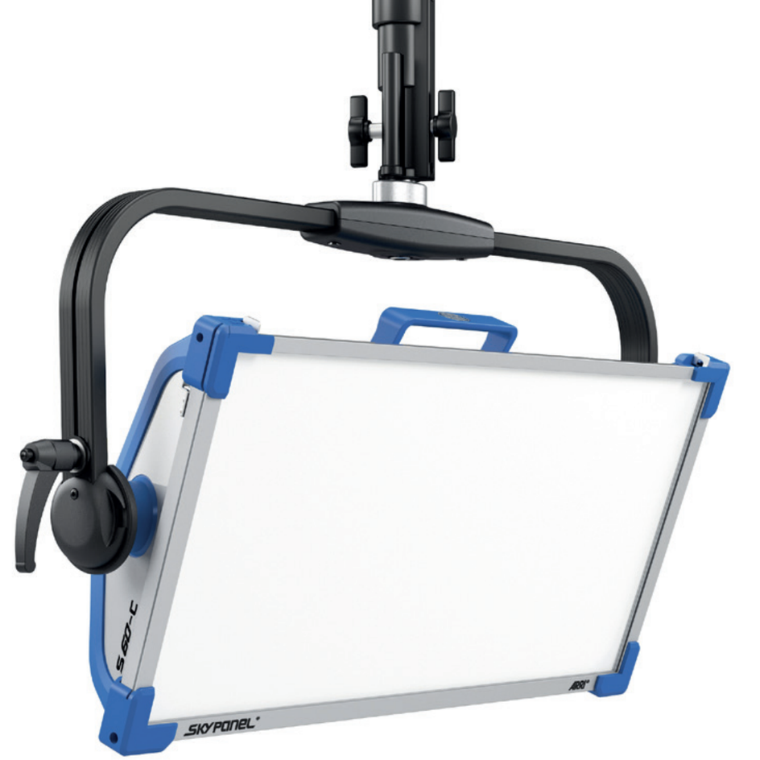
V2.0 – Single Page

S60-C
LED Soft Light
- General
The luminaire shall be a 400 W color mixing RGBW LED panel luminaire with an electronically controlled light source. The luminaire shall be capable of providing fully tunable white light from 2,800 to 10,000K and allow precise manipulation of intensity, green-magenta point (full minus green and full plus green), hue and saturation, RGBW control, xy control, gel and source color selection, and built-in effects. Control shall be possible via on-board control, wired remote control, DMX 512A with RDM capability, and ArtNet or sACN with DMX gateway capabilities. The luminaire shall be available as a manual and hanging pole operated.

- Physical
- The luminaire shall be constructed of rugged, aluminum and molded engineering grade fiber-reinforced thermoplastics.
- The body of the fixture shall be available in blue/silver or matt black finish.
- The luminaire shall have dimensions not exceeding 825 mm (32”) in length, 433 mm (17”) in height without spigot, and 133 mm (5.2”) in width.
- A tilt range of +/- 90° is required.

- Electrical
- The luminaire shall be furnished with an external power supply for 110 to 240 V AC 50/60 Hz supply voltage.
- The maximum power consumption shall be 400 W.
- An XLR 4-Pin port shall be implemented for battery power input in the range of 23 – 36 V DC
- The LED emitters used in the fixture should be rated for nominal 50.000-hour LED life to 70% intensity.
- The luminaire shall provide monitoring of the hours in use and the actual temperature.

- Optical
- The optical system shall offer an interchangeable diffusion panel with a half peak angle in the range of 71° – 116º.
- The luminaire should have soft, even beam of light and clean shadow rendition with following optical characteristics:
- Color rendition index CRI of > 95, TLCI of > 91
- Color temperature tolerance of +/- 100 K (nominal), +/- 1/8 Green-Magenta (nominal)
- The manufacturer shall ensure that there will be no differences in the quality of the light field between production batches of the lighting fixtures.
- The luminaire should have the following photometric characteristics:
 | 3 m / 9.8ft |  | 5 m / 16.4 ft |  | 7 m / 23.0 ft |  | 9 m / 29.5 ft
 | 3200K | 5600K | 3200K | 5600K | 3200K | 5600K | 3200K | 5600K
Standard Diffusion | 1305 lx | 1535 lx | 470 lx | 553 lx | 240 lx | 282 lx | 145 lx | 171 lx
Standard Diffusion | 121 fc | 143 fc | 44 fc | 51 fc | 22 fc | 26 fc | 13 fc | 16 fc

- Environmental
- The fixture shall hold the following Certifications & Declarations of Conformity - CE, UKCA, CB, ENEC, cNRTLus, FCC, PSE.

- Operation
- The luminaire shall offer thirteen 8 bit DMX profiles, thirteen 16 bit DMX profiles, and five coarse/fine DMX profiles, which can be pre-configured by the user.

- Accessories
- The following accessories shall be available, but are not limited to:
- 4-leaf barn-door
- Heavy, Lite, Standard, and Intensifier Panels
- 30º and 60° Honeycomb
- SkyBender
- 8-Chamber eggcrate
- Chimera and DoP Choice light banks

