V2.0 – Single Page

Orbiter
Versatile Point Source LED Light
Revision history

Date | Revision | Changes | Revisor
2021-05-31 | V1.0 | First release | AR
2021-07-14 | V1.1 | Technical corrections | AR
2023-09-06 | V2.0 | Additions | BD

- General
The luminaire shall be a 500 W RGBACL LED directional light luminaire with the ability to change the optical and mechanical accessories as needed. The luminaire shall be capable of providing fully tunable white light from 2,000 to 20,000K and allow precise manipulation of intensity, green-magenta point, hue and saturation, RGBW control, xy control, gel and source color selection, built-in effects, and via a built-in spectrometer. Control shall be possible via on-board control, wired remote control, DMX/RDM, ArtNet or sACN with DMX gateway capabilities, and built-in CRMX. The luminaire shall be available in manual and pole operated versions, with a yoke and optical accessories that can be attached without tools.

- Physical
- The luminaire shall be constructed of die cast aluminum, profiles and molded engineering grade fiber-reinforced thermoplastics, and shall be available in blue/silver or matt black finish.

- Electrical
- The luminaire shall be furnished with an internal power supply for 100 to 250 V~, 50/60 Hz supply voltage, with a nominal wattage of 400 W and a maximum wattage of 500 W.
- The LED emitters used in the fixture should be rated for nominal 50,000-hour LED life to 70% intensity with an estimated color shift over lifetime less than 200K.
- Two EtherCon LAN ports shall be implemented, incl. an integrated ethernet switch.
- A 3-Pin XLR port shall be implemented for 48V DC power input from a power station or battery.

- Optical
- The optical system shall offer an interchangeable accessory interface with power and bi-directional communication between and fixture and optical accessory.
- Color rendition index CRI of > 98, TLCI of > 95 and TM30 > 94 at 3,200 to 5,600 K
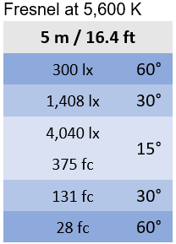
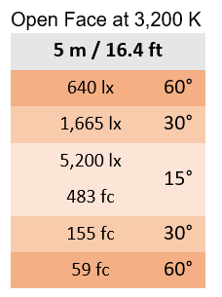
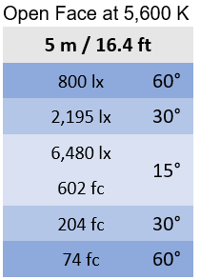
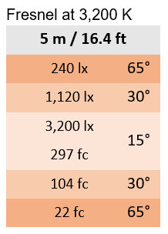
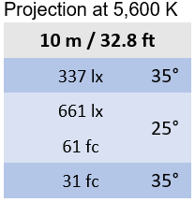
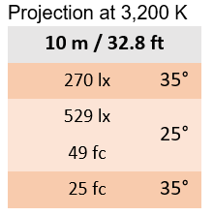
- The fixture should have the following photometric characteristics:

- Certification
- The fixture shall be compliant with CE standards as well as ENEC and FCC certified, and will carry a UL or equivalent listing.

- Operation
- The luminaire shall offer nine 8 bit DMX profiles, and nine 16 bit DMX profiles, which can be pre-configured by the user.

- Accessories
The following accessories shall be available:
- Open Face 15°, 30° and 60° incl. matching 4 or 8-leaf barndoor
- Fresnel with motorized zoom, offering beam angle between 15° - 65°
- 25° and 35° Projection optic that accepts B-size gobos and includes internal shutters for precise shaping of the beam.
- Omnidirectional Dome in four different sizes (S to XL)
- Softboxes in rectangular shape: DoPchoice Snapbag S & M and Chimera Light Banks S & M
- Softboxes in octagonal shape: Chimera Octa4 and DoPchoice Octa4
- Glass cover for direct illumination from the light engine

